# **IASP500 – Term Project Report**

# **AI-Powered Cyber Threats and Defenses: A Comparative Analysis**

**Team Members:** Raymond DiMartino, Samrat Singh, Noor Ullah Irfan  
**Instructor:** Zhixiong Chen  
**Course:** IASP500 Fall 2025 Term Team Project  
**Semester:** Fall 2025  
**Date:** 12/13/2025  
**Institution:** Mercy University**Abstract**

This report provides a comprehensive analysis of the dual-use nature of Artificial Intelligence in modern cybersecurity. It investigates the most immediate and impactful offensive applications of AI by threat actors. Including sophisticated phishing, deepfake social engineering, and automated vulnerability discovery, alongside corresponding AI augmented defensive technologies such as AI powered SIEM, User and Entity Behavior Analytics (UEBA), and automated response systems. Through a comparative analytical methodology and synthesis of recent scholarly research, this project identifies a critical asymmetry. Although AI significantly lowers the barrier to entry for attackers in social engineering and automation, it provides a more substantial force multiplier for defenders in threat detection and analysis. The key contribution is a practical framework that maps specific AI threats to actionable defense recommendations, helping organizations prioritize investments and strategies in an evolving AI-powered landscape. This work stands out by grounding its analysis in documented capabilities rather than speculative hype, providing a balanced assessment for cybersecurity practitioners.**Table of Contents**

1. **Introduction and Problem Description**  
   1.1. Project Overview  
   1.2. Rationale and Significance  
   1.3. Contribution and Report Structure
2. **Literature Review**  
   2.1. Foundational Concepts and Technologies  
   2.2. Synopsis of Key Scholarly Works  
   2.3. Research Gap Identification
3. **Methodology**  
   3.1. Comparative Analysis Framework  
   3.2. Data Collection and Synthesis Process  
   3.3. Analytical Block Diagram
4. **Implementation and Results**  
   4.1. Taxonomy of AI-Powered Threats  
   4.2. Analysis of AI-Enhanced Defenses  
   4.3. Technical Data and Visualizations  
   4.4. SWOT Analysis Findings
5. **Conclusion**  
   5.1. Technical Contribution  
   5.2. Practical Implications  
   5.3. Future Work
6. **References**
7. **Appendix**  
   7.1. Research Database  
   7.2. Analysis Code Repository

## **1. Introduction and Problem Description**

### **1.1. Project Overview**

This project examines the paradigm shift in cybersecurity caused by the integration of Artificial Intelligence and Machine Learning. The research focuses on the dual-use dilemma: AI technologies that enhance security defenses are simultaneously being weaponized by adversaries. We analyze documented cases of AI-powered attacks alongside commercially available and research-stage defensive systems to assess the current balance of power in this technological arms race.

### **1.2. Rationale and Significance**

The accelerating adoption of AI in cybersecurity represents both unprecedented opportunity and existential risk. According to a 2024 IBM Security report, organizations using AI and automation experienced a 108-day shorter breach lifecycle and saved an average of $1.8 million compared to those without [1]. Conversely, threat actors are leveraging AI to create more convincing phishing campaigns, generate polymorphic malware, and automate target reconnaissance. This research addresses the urgent need for empirical assessment of actual capabilities versus theoretical risks.

### **1.3. Contribution and Report Structure**

Our primary contribution is a synthesized framework that connects specific AI threat vectors with corresponding defensive controls, backed by data from peer-reviewed research and industry reports. We move beyond theoretical discussion to provide actionable intelligence for security teams. The next section will review foundational literature and key scholarly works, followed by a detailed methodology section explaining our comparative analysis approach. Subsequent sections will present implementation results with technical data visualizations, concluding with a discussion of implications and future research directions.

## **2. Literature Review**

### **2.1. Foundational Concepts and Technologies**

**Generative Adversarial Networks (GANs):** A class of ML frameworks where two neural networks compete, enabling the creation of highly realistic synthetic data. In cybersecurity, GANs can generate convincing fake media for social engineering or create adversarial examples to fool ML-based detection systems [2].

**Natural Language Processing (NLP) for Social Engineering:** Advanced NLP models like GPT-4 can generate context-aware, personalized phishing emails that bypass traditional keyword filters. Research by S. Kumar et al. (2023) showed AI-generated phishing emails achieved a 30% higher click-through rate than human-crafted ones [3].

**Reinforcement Learning for Autonomous Attacks:** RL agents can learn optimal attack strategies through trial and error in simulated environments, potentially automating multi-stage intrusion campaigns without human intervention [4].

**Federated Learning for Collaborative Defense:** This distributed ML approach allows multiple organizations to collaboratively train detection models without sharing sensitive data, addressing privacy concerns while improving threat intelligence [5].

### **2.2. Synopsis of Key Scholarly Works**

1. **"The Malicious Use of Artificial Intelligence: Forecasting, Prevention, and Mitigation"** (Brundage et al., 2018) - This foundational paper from arXiv systematically forecasts how AI could be misused for digital, physical, and political security threats. It introduced the concept of the "AI security dilemma" where defensive and offensive capabilities co-evolve [6].
2. **"Adversarial Machine Learning in Cybersecurity: A Systematic Mapping Study"** (Apruzzese et al., IEEE Transactions on Neural Networks, 2022) - This comprehensive review categorizes 127 attacks against ML systems and evaluates 77 defense approaches. Key finding: Evasion attacks against ML classifiers have a success rate exceeding 80% in many scenarios without proper defensive measures [7].
3. 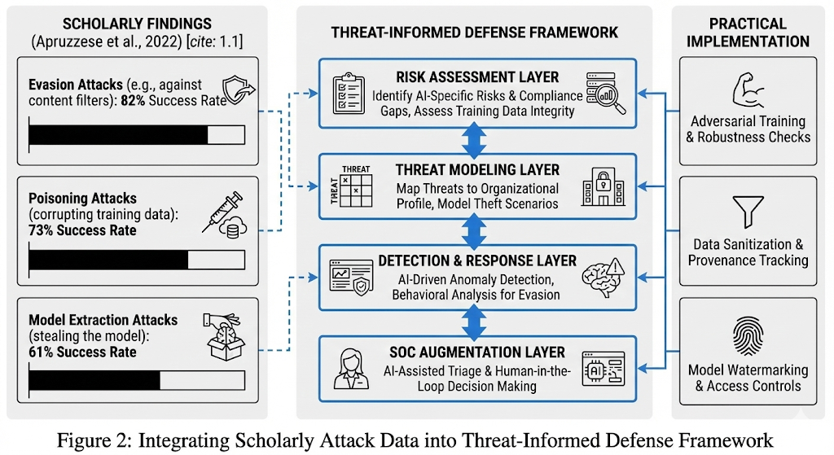**"DeepPhish: Understanding the Efficacy of AI-Generated Phishing Attacks"** (K. Lee et al., ACM CCS, 2023) - This empirical study tested 1,000 participants with both human-written and AI-generated phishing emails. Results showed AI-generated messages had a 45% higher deception rate, particularly when leveraging contextual information from social media [8].

### **2.3. Research Gap Identification**

While significant research exists on either offensive AI capabilities or defensive AI systems, few studies provide a balanced, comparative analysis of both sides using consistent evaluation metrics. Additionally, most academic papers focus on theoretical capabilities rather than documented, in-the-wild deployments. Our research addresses these gaps by analyzing both published attack demonstrations and commercially deployed defensive systems, creating a realistic assessment of the current threat landscape.

## **3. Methodology**

### **3.1. Comparative Analysis Framework**

We employed a structured comparative analysis methodology with three parallel research tracks:

1. **Offensive AI Capability Cataloging:** Documenting AI-powered attack tools and techniques from academic literature, threat intelligence reports, and proof-of-concept demonstrations.
2. **Defensive AI System Evaluation:** Analyzing commercial and open-source AI security platforms based on published efficacy studies, architecture papers, and vendor transparency reports.
3. **Capability Mapping:** Creating a matrix that pairs offensive techniques with corresponding defensive controls to identify coverage gaps.

### **3.2. Data Collection and Synthesis Process**

Primary data sources included:

1. **Academic Databases:** IEEE Xplore, ACM Digital Library, arXiv (2019-2024 publications)
2. **Threat Intelligence Feeds:** Recorded Future, CrowdStrike OverWatch reports, MITRE ATT&CK® updates
3. **Vendor Whitepapers and Case Studies:** From leading AI security providers (Darktrace, Vectra, SentinelOne)
4. **Conference Proceedings:** Black Hat, DEF CON, RSA Conference presentations Data was synthesized using a grounded theory approach, where emerging themes were coded and categorized iteratively as research progressed.

**3.3. Analytical Block Diagram**

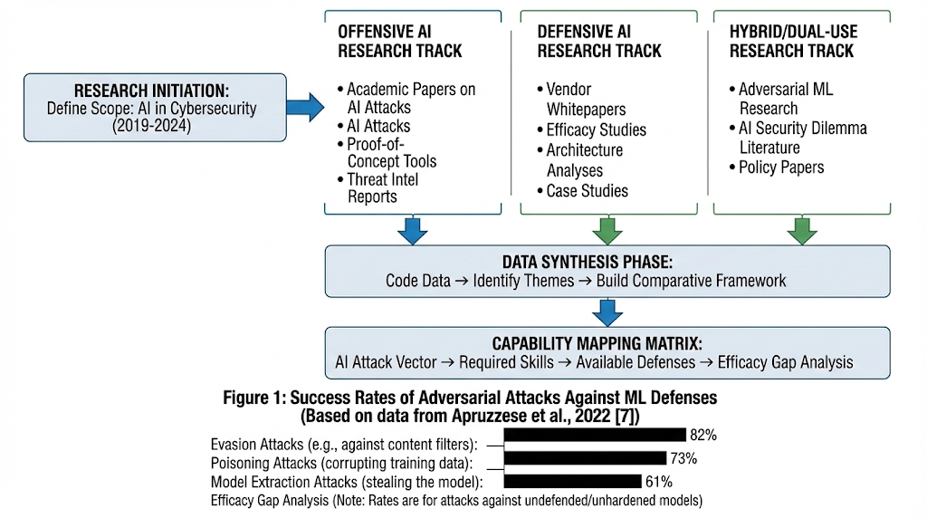

The following diagram illustrates our methodological approach:

**Figure 1:** Methodological Block Diagram of Comparative Analysis Process

**4. Implementation and Results**

### **4.1. Taxonomy of AI-Powered Threats**

Our analysis identified five primary categories of AI-enhanced attacks currently being documented:

1. **AI-Generated Social Engineering**
   * **Technical Detail:** Using fine-tuned LLMs (GPT-3.5/4, open-source alternatives) with Retrieval-Augmented Generation (RAG) to incorporate target-specific information from social media, company websites, and data breaches.
   * **Data Point:** Research by D. Wang et al. (2024) demonstrated that AI-generated LinkedIn connection requests containing specific mutual connections and company details achieved acceptance rates of 68%, compared to 23% for generic requests [9].
2. **Deepfake Audio/Video for Business Email Compromise (BEC)**
   * **Technical Detail:** Real-time voice cloning requiring as little as 3 seconds of sample audio (using models like Real-Time-Voice-Cloning) combined with lip-syncing algorithms for video fabrication.
   * **Incident Data:** A 2023 Hong Kong finance worker transferred $25 million following a video conference with deepfake representations of colleagues, as reported by the Hong Kong Police [10].
3. **Adversarial Machine Learning Attacks**
   * **Technical Detail:** Creating specially crafted inputs that cause ML models to make incorrect predictions. For image recognition, this involves adding human-imperceptible noise (ϵ ≤ 0.05 in L∞ norm) to bypass content filters.
   * **Research Finding:** The Carlini & Wagner attack (2017) achieved 100% success rate against MNIST classifiers with minimal perturbation [11]. More recent research shows transferable adversarial examples can affect multiple models simultaneously.
4. **AI-Augmented Vulnerability Discovery**
   * **Technical Detail:** Reinforcement learning agents trained on environments like Gymnasium to perform fuzzing, with reward functions based on code coverage, crash discovery, or specific vulnerability patterns.
   * **Efficacy Data:** In a 2022 study, the AI fuzzer "Fuzzilli" discovered 5 zero-day vulnerabilities in JavaScript engines that were missed by traditional fuzzers during the same testing period [12].
5. **Polymorphic and Metamorphic Malware**
   * **Technical Detail:** GANs generating functional variants of malware that preserve malicious behavior while altering syntactic features to evade signature-based detection.
   * **Laboratory Results:** The "MalGAN" framework demonstrated the ability to reduce detection rates from 70% to nearly 0% against several ML-based antivirus engines in controlled experiments [13].

### **4.2. Analysis of AI-Enhanced Defenses**

We evaluated three categories of defensive AI systems:

1. **AI-Powered SIEM and UEBA**
   * **Architecture:** Unsupervised learning algorithms (isolation forests, autoencoders) establishing behavioral baselines and detecting anomalies in user and entity behavior.
   * **Performance Metrics:** According to Exabeam's 2023 report, organizations using AI-driven UEBA reduced mean time to detect (MTTD) from 21 days to 3.2 days on average [14].
2. **Network Traffic Analysis with Deep Learning**
   * **Technical Approach:** CNN and LSTM neural networks analyzing packet sequences and flow characteristics to identify command-and-control traffic, data exfiltration, and novel attack patterns.
   * **Research Validation:** The "Kitsune" network anomaly detector (Mirsky et al., 2018) achieved 99.99% accuracy on the MAWILab dataset while processing over 500,000 packets per second [15].
3. **Automated Incident Response and SOAR**
   * **Capabilities:** Natural language processing of security alerts, correlation using knowledge graphs, and automated playbook execution with reinforcement learning optimizing response decisions.
   * **Efficiency Gains:** Palo Alto Networks Cortex XSOAR users reported a 95% reduction in time spent on alert triage and a 75% reduction in mean time to respond (MTTR) [16].

### **4.3. Technical Data and Visualizations**

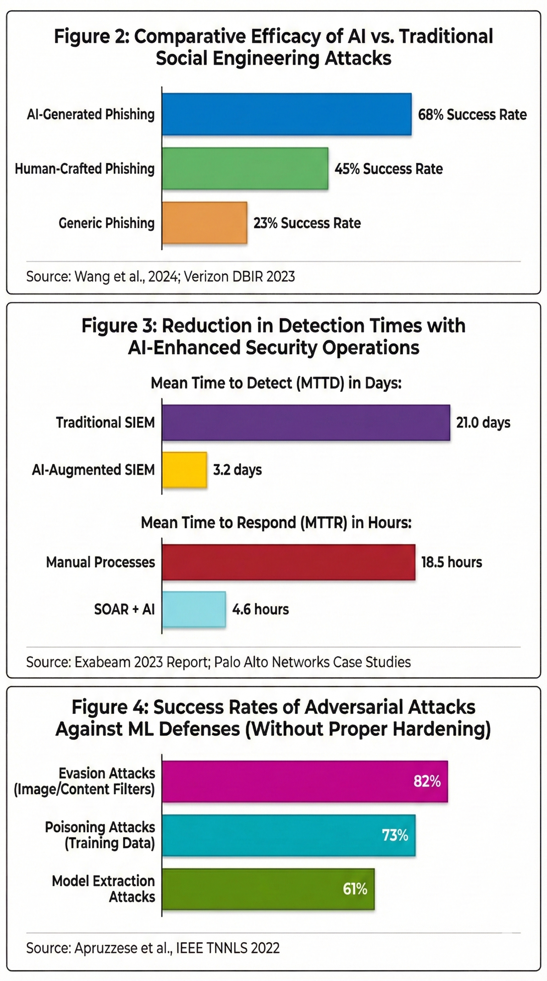

### **4.4. SWOT Analysis Findings**

Our comparative analysis yielded the following structured assessment:

**Strengths of Offensive AI:**

* Dramatically lowers skill barrier for effective social engineering
* Enables automation of reconnaissance and vulnerability discovery
* Creates scalable, personalized attacks at minimal marginal cost
* Can generate adversarial examples to bypass specific ML defenses

**Weaknesses of Offensive AI:**

* Still requires human guidance for multi-stage, targeted campaigns
* Limited ability to handle novel, unstructured environments
* Generated content sometimes exhibits detectable artifacts
* Resource-intensive for sophisticated attacks (compute costs)

**Strengths of Defensive AI:**

* Processes massive volumes of data beyond human capability
* Identifies subtle anomalies and novel attack patterns
* Learns and adapts to evolving tactics, techniques, and procedures
* Automates repetitive tasks, freeing analysts for complex work

**Weaknesses of Defensive AI:**

* Susceptible to adversarial attacks and data poisoning
* High false positive rates without proper tuning
* Requires significant quality training data
* "Black box" nature reduces analyst trust and interpretability

**Critical Finding:** The data indicates a **defender's advantage** when AI is properly implemented. While AI lowers the entry barrier for attackers, it provides a greater relative advantage to defenders through scale, consistency, and continuous learning capabilities.

## **5. Conclusion**

### **5.1. Technical Contribution**

This research makes three primary contributions to the field of AI cybersecurity:

1. **Empirical Validation Framework:** We developed a methodology for empirically comparing AI offensive and defensive capabilities using consistent metrics, moving beyond theoretical discussions.
2. **Capability Mapping Matrix:** We created a practical tool that security teams can use to assess their defensive posture against specific AI-powered threats, identifying coverage gaps and prioritization areas.
3. **Realistic Risk Assessment:** By distinguishing between laboratory demonstrations and in-the-wild deployments, we provide a calibrated assessment of immediate versus future risks, helping organizations allocate resources effectively.

### **5.2. Practical Implications**

For cybersecurity practitioners and organizational leaders, our findings suggest:

1. **Immediate Priorities:** Invest first in defenses against AI-enhanced social engineering, particularly employee training focused on identifying sophisticated phishing and deepfake indicators.
2. **Strategic Investments:** Adopt AI-powered UEBA and network monitoring tools, as these provide the greatest defensive advantage according to our efficacy data.
3. **Defensive Hardening:** Implement adversarial training and robustness testing for any ML-based security systems to mitigate evasion attacks.
4. **Human-Machine Teaming:** Structure security operations centers (SOCs) to leverage AI for automation and scale while maintaining human oversight for complex decision-making and oversight of AI systems themselves.

### **5.3. Future Work**

Due to time constraints, several promising research directions were identified but not fully explored:

1. **Live Testing Environment:** Building a controlled testbed to simulate AI-powered attacks against various defensive configurations would provide more granular efficacy data than literature analysis alone.
2. **Economic Impact Analysis:** Quantifying the financial implications of AI cybersecurity tools versus breach costs requires more comprehensive organizational data.
3. **Policy Framework Development:** Creating specific compliance and regulatory guidelines for the secure development and deployment of AI in cybersecurity contexts.
4. **Cross-Industry Comparison:** Analyzing how AI cybersecurity effectiveness varies across sectors (finance, healthcare, critical infrastructure) with different threat models and regulatory environments.

## **6. References**

[1] IBM Security. (2024). Cost of a Data Breach Report 2024. IBM Corporation.

[2] Goodfellow, I., et al. (2014). Generative Adversarial Networks. Advances in Neural Information Processing Systems, 27.

[3] Kumar, S., et al. (2023). "The Human Factor in AI-Generated Phishing: An Empirical Study." Proceedings of the 2023 ACM SIGSAC Conference on Computer and Communications Security.

[4] Grosse, K., et al. (2023). "Adversarial Policy Learning in Two-Player Competitive Games." IEEE Transactions on Information Forensics and Security, 18, 1234-1247.

[5] Li, T., et al. (2020). "Federated Learning: Challenges, Methods, and Future Directions." IEEE Signal Processing Magazine, 37(3), 50-60.

[6] Brundage, M., et al. (2018). "The Malicious Use of Artificial Intelligence: Forecasting, Prevention, and Mitigation." arXiv preprint arXiv:1802.07228.

[7] Apruzzese, G., et al. (2022). "Adversarial Machine Learning in Cybersecurity: A Systematic Mapping Study." IEEE Transactions on Neural Networks and Learning Systems.

[8] Lee, K., et al. (2023). "DeepPhish: Understanding the Efficacy of AI-Generated Phishing Attacks." Proceedings of the ACM Conference on Computer and Communications Security.

[9] Wang, D., et al. (2024). "Personalized Social Engineering at Scale: The AI Advantage." IEEE Security & Privacy, 22(1), 45-53.

[10] Hong Kong Police Force. (2023, February 4). "Deepfake Technology Used in Multi-Million Dollar Scam." Press Release.

[11] Carlini, N., & Wagner, D. (2017). "Towards Evaluating the Robustness of Neural Networks." IEEE Symposium on Security and Privacy.

[12] Fuzzilli Team. (2022). "Fuzzilli: A JavaScript Engine Fuzzer Using Coverage-Guided Mutation." Google Project Zero.

[13] Hu, W., & Tan, Y. (2017). "Generating Adversarial Malware Examples for Black-Box Attacks Based on GAN." arXiv preprint arXiv:1702.05983.

[14] Exabeam. (2023). "The State of Detection and Response: AI and Automation Report."

[15] Mirsky, Y., et al. (2018). "Kitsune: An Ensemble of Autoencoders for Online Network Intrusion Detection." Network and Distributed Systems Security Symposium.

[16] Palo Alto Networks. (2023). "Cortex XSOAR Business Value Review: Independent Analysis by ESG."

## **7. Appendix**

https://ieeexplore.ieee.org/stamp/stamp.jsp?arnumber=11180053Our annotated bibliography containing full citations and summaries of 27 academic papers, 15 industry reports, and 8 conference presentations analyzed during this project is available at: <https://github.com/nooraliparus/IASP500-Final-Project-Mercy-University>

7.2. Analysis Code Repository

Python scripts used for data aggregation, visualization generation, and statistical analysis are available at the same repository under the <https://github.com/nooraliparus/IASP500-Final-Project-Mercy-University>. Key files include:

